**CTEDC**

**Comanche Maps**

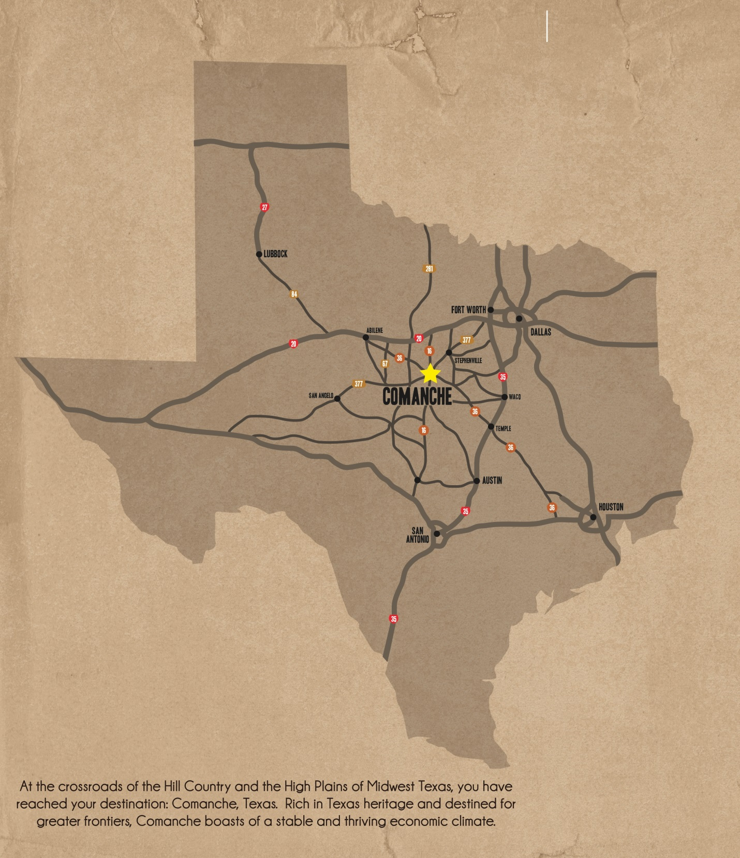

**CTEDC**

**Comanche Maps**

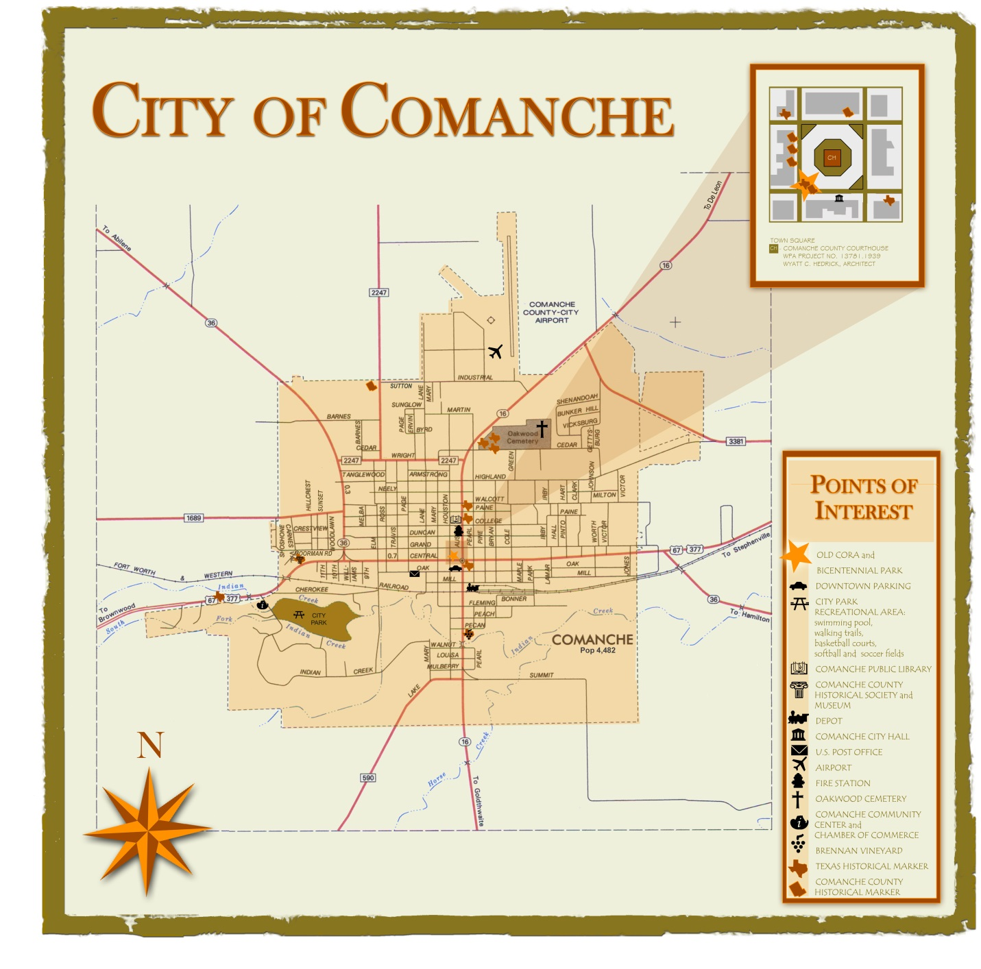

**CTEDC**

**Comanche Maps**

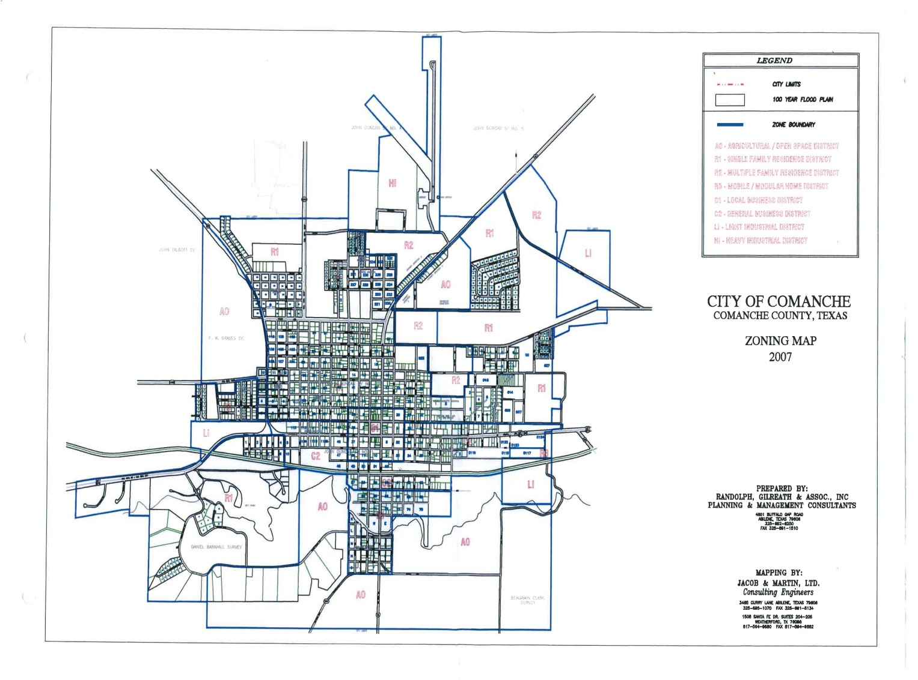

**CTEDC**

**Comanche Maps**

**Airport Industrial Park**

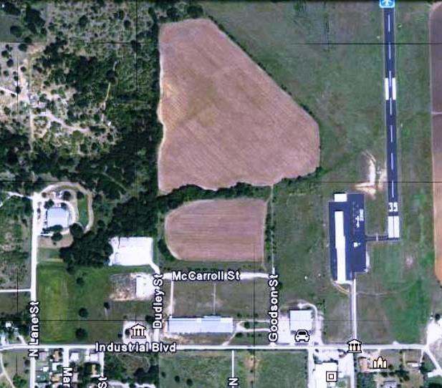

**CTEDC**

**Comanche Maps**

**EDC Business Park**

